**LAB TASK 9**

Task1:

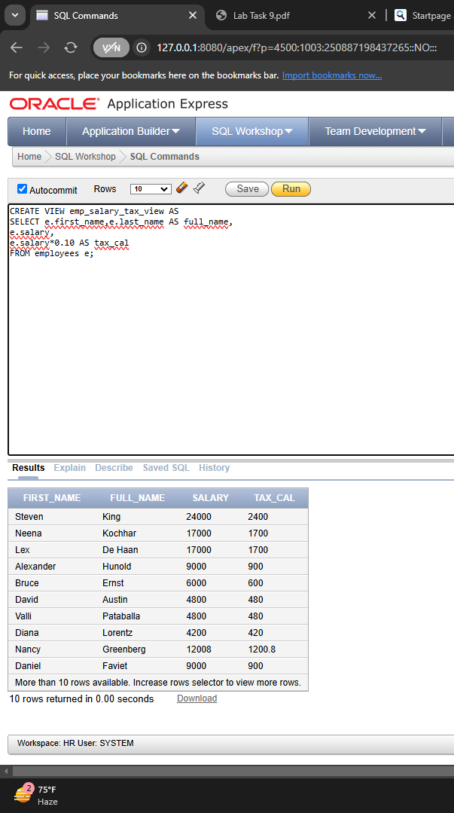

Task 2:

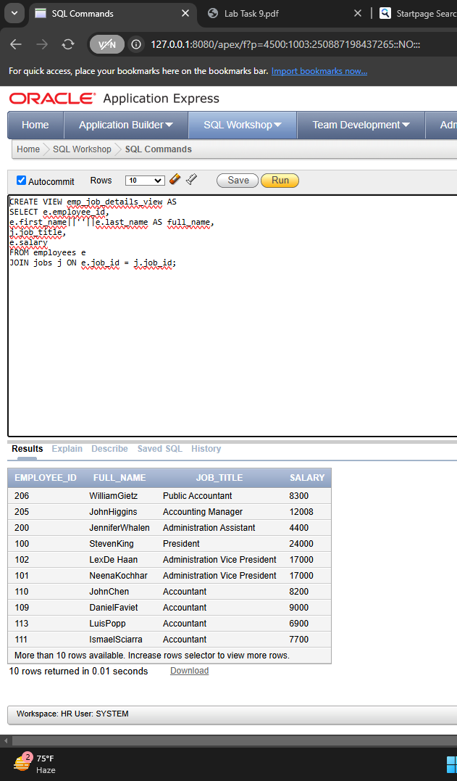

Task 3:

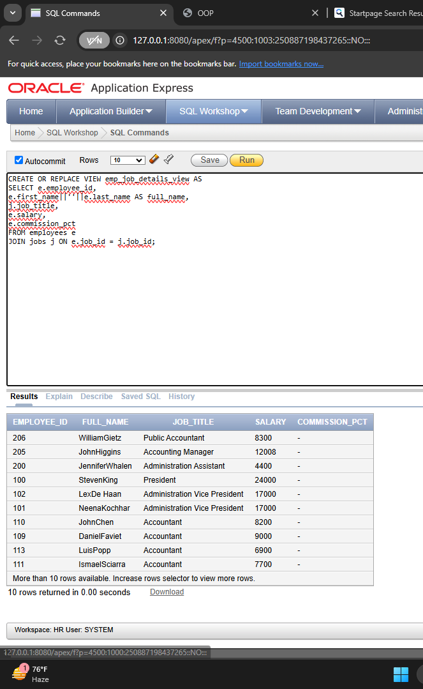

Task 4:

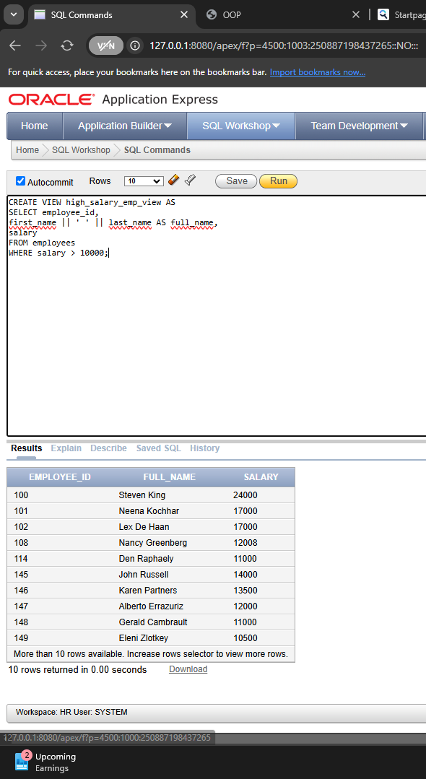

Task 5 part1:

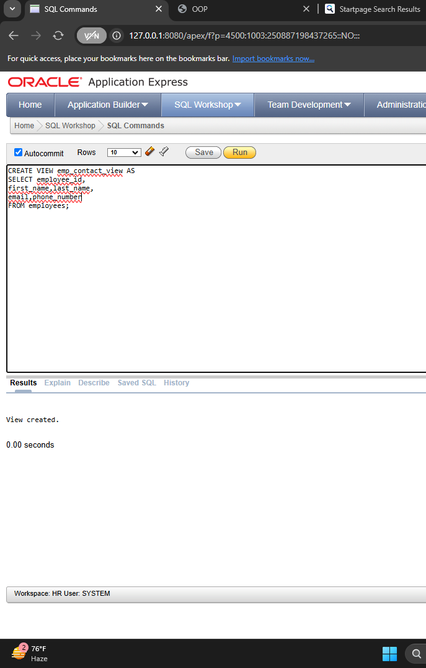

Lab task 9 task 5 part 2

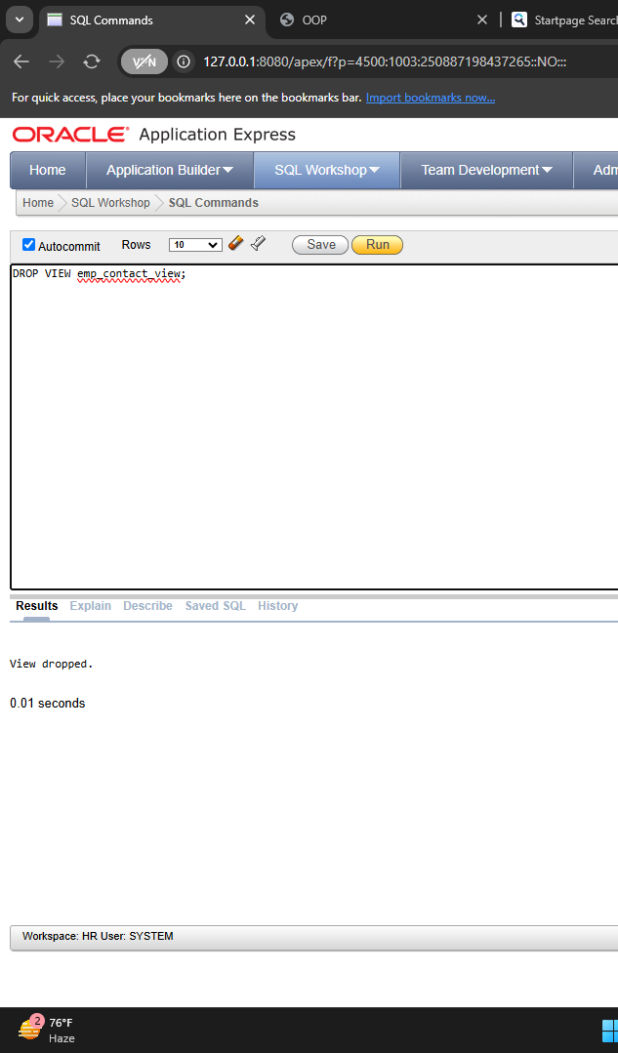

Task 6

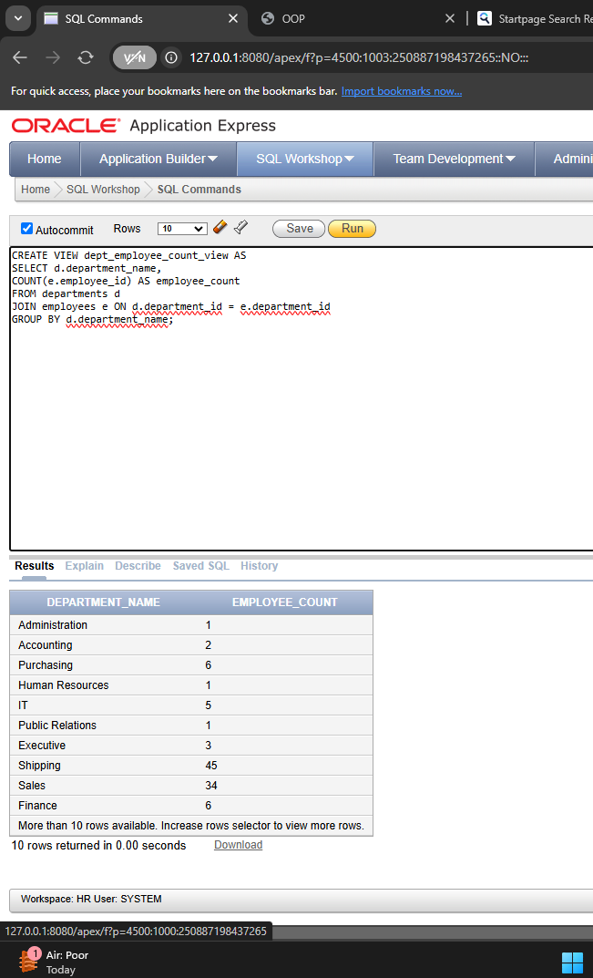

Task 7:

The output of SELECT * FROM emp_dept_view will display a list of employees with department names. Each row contains the employee's ID, full name (||’ ’|| first and last name), and the department they belong to.